Assignment 10
DHCP Configuration

- In Cisco Packet Tracer, set up a simple network with one DHCP server and two client PCs. Configure the DHCP server to assign IP addresses automatically, then verify on each PC that it receives a different IP address from the DHCP pool.

Result: In Cisco Packet Tracer, I configured one DHCP server with a starting IP address of 192.168.1.10 and connected two client PCs. Both PCs received different IP addresses automatically from the DHCP pool.

- PC0: 192.168.1.10
- PC1: 192.168.1.11

- Conclusion: DHCP successfully assigned unique IP addresses to both PCs automatically, without requiring manual IP configuration.
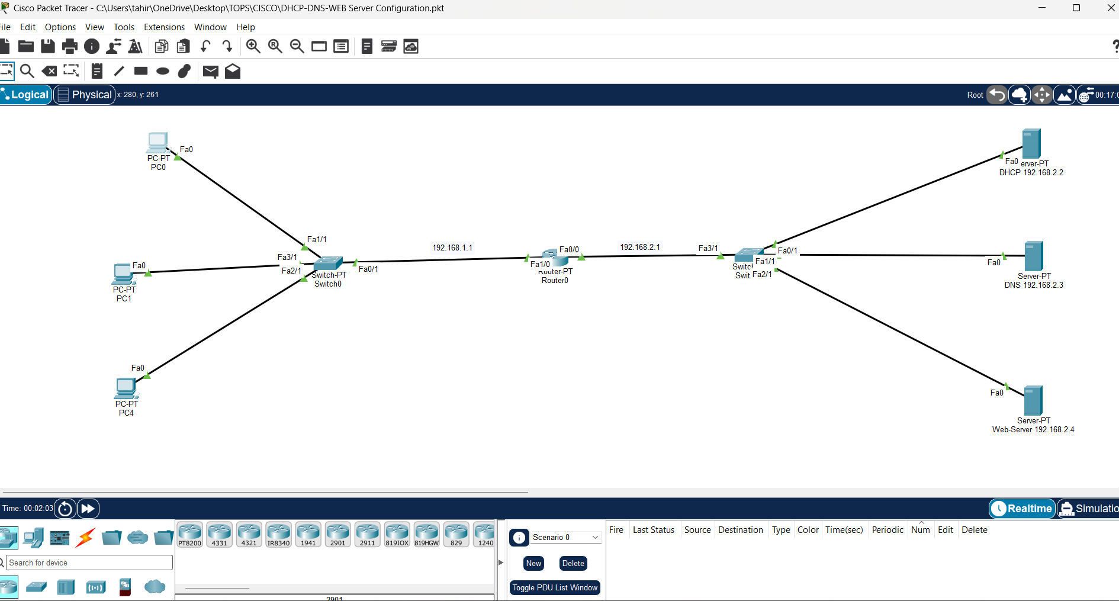

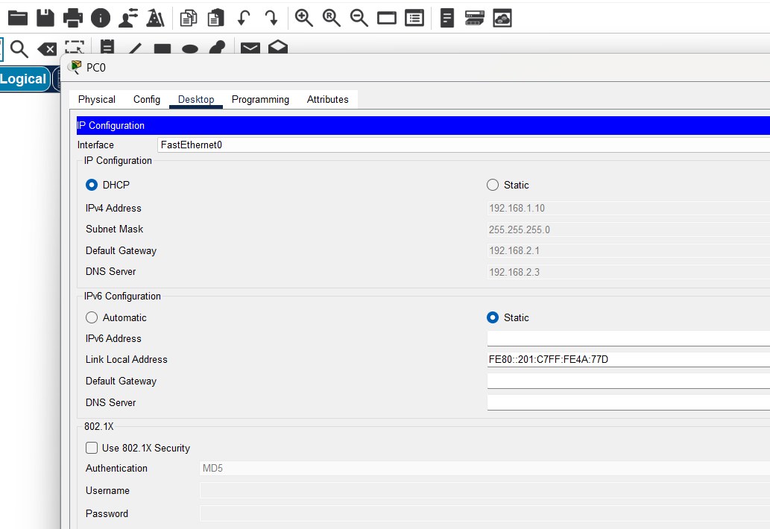
- Draw a sequence diagram (hand-drawn or digital) that clearly shows each step of the DHCP process: Discover, Offer, Request, and Acknowledge, labeling the sender and receiver at each stage. Hint: Use arrows to show the direction of each message between client and server.

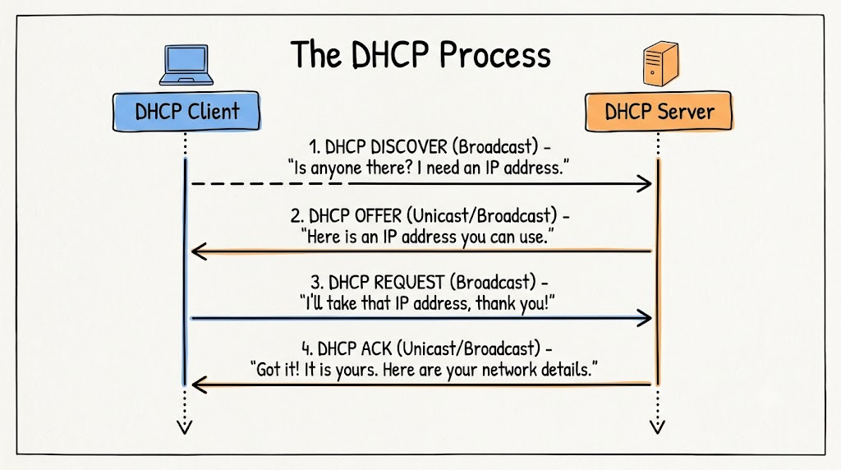

  - Discover (Client ➡️ Server): The client broadcasts a message asking if there is an IP address available for use.

  - Offer (Server ➡️ Client): A DHCP server responds back with an available IP address option.

  - Request (Client ➡️ Server): The client broadcast-requests to accept that offered IP address.

  - Acknowledge (Server ➡️ Client): The server confirms the reservation and sends the required network details (subnet mask, DNS, gateway) to finish the setup.

- Change the DHCP pool range on your Cisco Packet Tracer DHCP server so that only one IP address is available. Add two PCs and observe what happens when both try to get an IP address. Take a screenshot of the result and explain in 2-3 lines why only one PC succeeds.

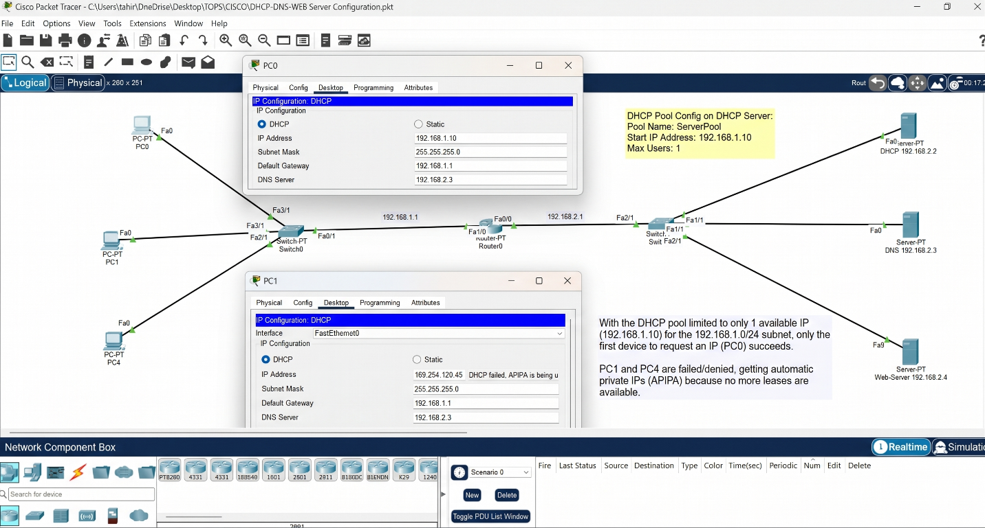

- Simulate a Zomato-style restaurant WiFi scenario in Cisco Packet Tracer: configure a DHCP server to provide IP addresses to both a laptop and a smartphone (use a generic PC as smartphone). Show the assigned IPs and explain why DHCP is useful in this situation.



